**ArcGIS pro 3.1.0 (Done this practically)**

A geographic information system (GIS) is a way to display and analyze data using maps. In this tutorial, you'll learn the basics of ArcGIS Pro, a desktop GIS application.

A Singapore tourism agency wants to create a brochure that tells visitors the closest rail station to popular destinations in the downtown area. The brochure will combine a map with textual information and be sold at kiosks around the city. You'll help the agency by mapping the tourist sites, analyzing how close they are to rail stations, and changing the map's appearance so that it is visually appealing.

*This tutorial was last tested on March 6, 2023, using ArcGIS Pro 3.1. If you're using a different version of ArcGIS Pro, you may encounter different functionality and results.*

[View final result](https://downloads.esri.com/LearnArcGIS/get-started-with-arcgis-pro/downtown-singapore.png" \t "https://learn.arcgis.com/en/projects/get-started-with-arcgis-pro/_blank)

#### Requirements

* User, Publisher, or Administrator role in an ArcGIS organization: ArcGIS Online ([see options for software access](https://learn.arcgis.com/en/become-a-member/)) or ArcGIS Enterprise ([learn more](https://learn.arcgis.com/en/related-concepts/enterprise.htm))
* ArcGIS Pro ([see options for software access](https://learn.arcgis.com/en/become-a-member/))

## Create a project

In ArcGIS Pro, maps and data are organized in a project. Before you begin your map, you'll create a project. You can complete the tutorial using an ArcGIS Online account or an ArcGIS Enterprise account, as long as ArcGIS Pro is licensed in your portal.

1. Start ArcGIS Pro. If prompted, sign in using your licensed ArcGIS organizational account.

##### Note:

If you don't have access to ArcGIS Pro or an ArcGIS organizational account, [see options for software access](https://learn.arcgis.com/en/become-a-member/).

Under **New Project**, click **Map**.

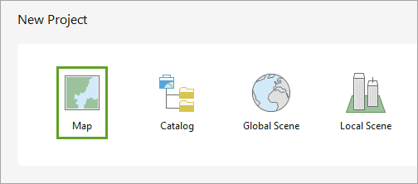

The **Create a New Project** window appears. By default, projects are saved in a new folder. To save them in an existing folder, uncheck **Create a new folder for this project** and browse to the folder.

For **Name**, delete the existing text and type Singapore Tourism. Leave **Location** unchanged and confirm that **Create a new folder for this project** is checked.

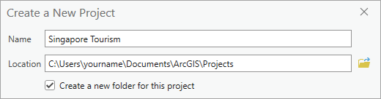

##### Note:

Your default location may differ from the example image. Typically, projects are saved in the ArcGIS folder that was created when you installed ArcGIS Pro.

Click **OK**.

The project is created with a map showing the world. In ArcGIS Pro, maps are composed of layers of geographic data. For now, the only layer is the basemap, which provides reference information such as national boundaries and water bodies.

##### Note:

Depending on your ArcGIS organization's settings, your map may have a different default extent and basemap, so it may look different than the example image.

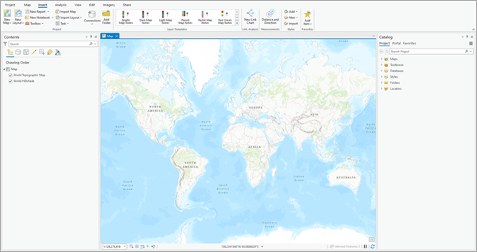

On either side of the map are panes. By default, the **Contents** and **Catalog** panes are open, although other panes may be open if you've used ArcGIS Pro before. The **Contents** pane lists the layers on the map and the **Catalog** pane lists all files associated with the project.

Above the map is the ribbon. The ribbon contains several tabs, each with multiple buttons. These buttons may affect map navigation, change the map's appearance, or open windows or panes with more functionality.

##### Tip:

You can rearrange panes by dragging their title and docking them in new locations. You can also resize panes by dragging their edges. To return to the default pane arrangement, click the **View** tab. In the **Windows** group, click **Reset Panes** and choose **Reset Panes for Mapping**. Throughout this tutorial, feel free to arrange the panes and views.

## Navigate to Singapore

Your area of interest is the island city-state of Singapore, so you'll navigate to it.

1. On the ribbon, click the **Map** tab.

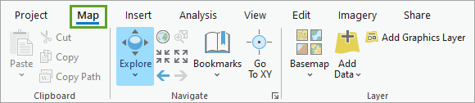

1. In the **Inquiry** group, click the **Locate** button.

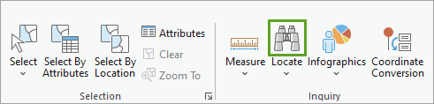

The **Locate** pane appears. Using this pane, you can search for and navigate to geographic locations, including countries, cities, and street addresses.

1. In the **Locate** pane, in the search bar, type Singapore and press Enter.

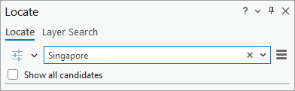

The map automatically navigates to the first result: the country of Singapore. (The locations of the search results are displayed on the map as circles.)

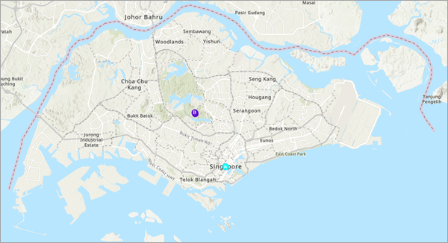

Singapore, one of the world's smallest nations, is home to 5.6 million people and has four official languages. The modern city contains numerous historical and cultural landmarks, entertainment venues, and ecological sites. It is one of the most visited cities in the world and tourism is a major industry.

Close the **Locate** pane.

Above the ribbon, on the Quick Access Toolbar, click the **Save** button.

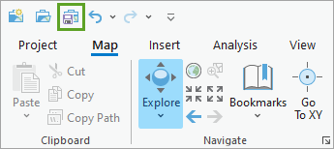

## Add data

The basemap shows Singapore and some basic geographic information, such as roads and lakes. However, it doesn't show tourist destinations or rail stations. To create a map that is useful to tourists, you'll add this data to the map.

1. On the ribbon, on the **Map** tab, in the **Layer** group, click the **Add Data** button.

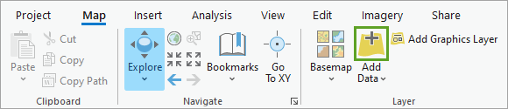

The **Add Data** window appears. You can add data from several sources, including your project's folder (**Project**), the website of your ArcGIS account (**Portal**), or your computer (**Computer**).

Most ArcGIS accounts, including trial accounts, use the ArcGIS Online website as their portal. [ArcGIS Online](https://www.esri.com/en-us/arcgis/products/arcgis-online/overview" \t "https://learn.arcgis.com/en/projects/get-started-with-arcgis-pro/_blank) is an online GIS mapping platform that hosts a large amount of spatial data. You'll add the data you need from there.

1. In the **Add Data** window, under **Portal**, click **ArcGIS Online**.

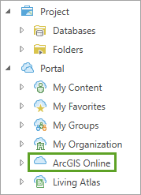

This option provides access to all data hosted on ArcGIS Online. The data you'll use is owned by the Learn ArcGIS administrator account. To find the data, you'll search for it by name and owner.

1. In the search bar, type Singapore owner:Learn_ArcGIS and press Enter.

The search returns three results: **Singapore Rail Lines**, **Singapore Tourist Attractions**, and **Singapore Rail Stations**.

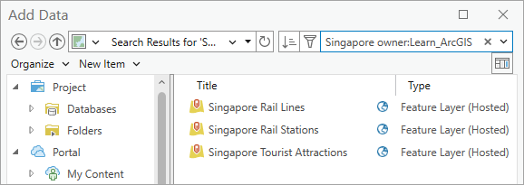

##### Note:

Some ArcGIS accounts use an [ArcGIS Enterprise](https://enterprise.arcgis.com/en/" \t "https://learn.arcgis.com/en/projects/get-started-with-arcgis-pro/_blank) website as their portal. If your account uses ArcGIS Enterprise, you can't search for ArcGIS Online content. To add the data, go to the [Singapore_Data_gdb](https://www.arcgis.com/home/item.html?id=b6c521bf02fc46b8887c7af0d071b483" \t "https://learn.arcgis.com/en/projects/get-started-with-arcgis-pro/_blank) item on ArcGIS Online and click **Download**. Extract the downloaded folder to a location on your computer. In the **Add Data** window, browse to the location of the extracted folder. (You may need to click the **Refresh** button in the **Add Data** window to see the folder.)

1. While pressing the Ctrl key, click the **Singapore Rail Lines**, **Singapore Tourist Attractions**, and **Singapore Rail Stations** layers to select them.
2. Click **OK**.

The three data layers are added to the map.

##### Note:

If you're using ArcGIS Enterprise and downloaded the data instead of adding it from ArcGIS Online, your layers may look different than in the example images.

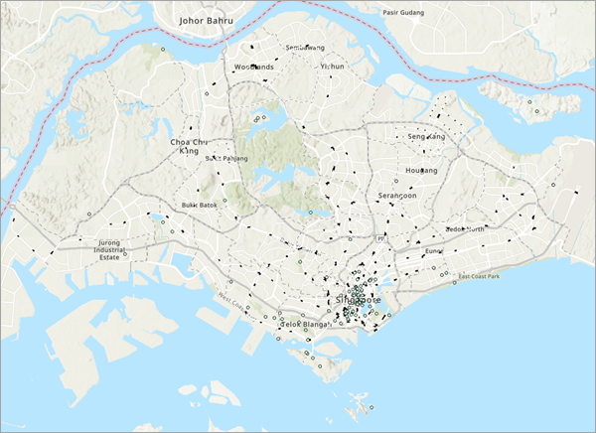

The layers are also listed in the **Contents** pane.

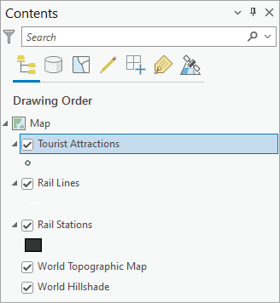

The green points are tourist attractions, the white lines are rail lines, and the black polygons are rail stations. Layers that are composed of points, lines, or polygons are called feature layers.

The majority of tourist attractions are grouped in the south-central part of the island. This area is Singapore's downtown, also called the Central Business District. The tourism agency wants their brochure to focus on this area, so you'll zoom to it.

1. On the map, point to downtown Singapore and move the mouse wheel to zoom in. Zoom until the downtown area takes up most of the map.

##### Tip:

Another way to zoom to an area is to select the **Explore** tool and press the Shift key while drawing a box on the map where you want to zoom. Alternatively, right-click and drag the mouse on the map to zoom in or out. Use the navigation method you prefer.

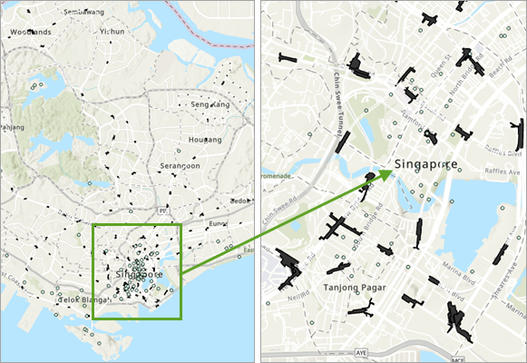

1. If necessary, drag the map to pan it until the Central Business District is in the center of the map.

At this extent, the rail stations are displayed in more detail. Depending on the size of your monitor, more information about streets and buildings may be displayed.

This map extent will be the one you use for the rest of the project. It'll be convenient to quickly return to this extent if needed, so you'll create a navigation shortcut called a bookmark.

1. On the ribbon, on the **Map** tab, in the **Navigate** group, click **Bookmarks** and choose **New Bookmark**.

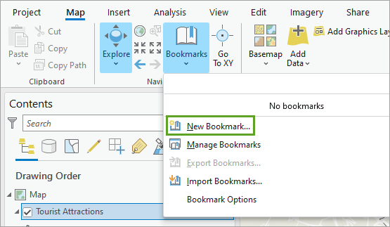

1. In the **Create Bookmark** window, for **Name**, type Central Business District.

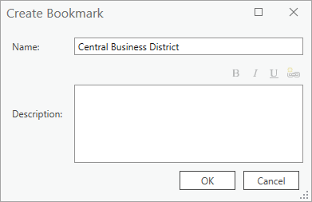

1. Click **OK**.

The bookmark is created. You'll use this bookmark later in the tutorial.

1. Save the project.

## Style the map

While navigating the map, you may have noticed that some of the data layers are difficult to see. The rail lines, for instance, are white and often blend into the other information on the map.

The information about streets, water bodies, and buildings comes from the basemap. A basemap provides reference information that contextualizes your data. ArcGIS Pro includes several basemap layers, with the default being **World Topographic Map**. (Depending on your ArcGIS organization's settings, you may have a different default basemap.)

You'll change the basemap to one that emphasizes your data. A darker basemap will make the white rail lines appear more clearly.

1. On the **Map** tab, in the **Layer** group, click **Basemap** and choose **Dark Gray Canvas**.

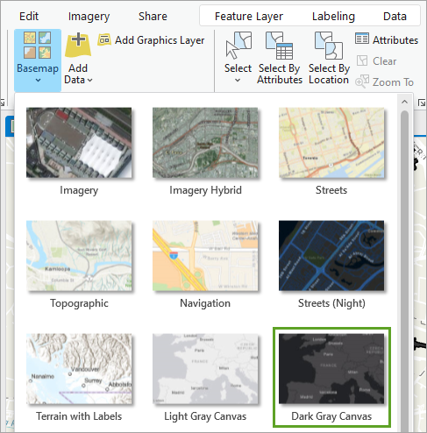

The basemap changes.

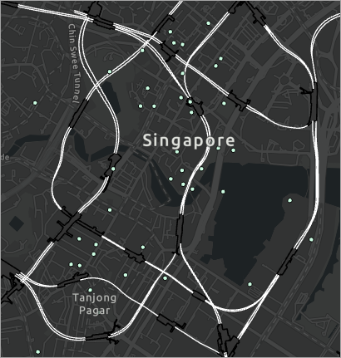

With this basemap, the rail lines stand out more. Unlike the **Topographic** basemap, this basemap contains two layers. One of these layers, **Dark Gray Reference**, contains text that labels some areas. This text isn't necessary for your map's purpose and may obscure some features, so you'll turn it off.

1. In the **Contents** pane, uncheck the **Dark Gray Reference** check box.

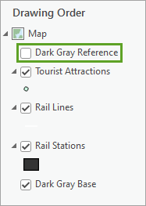

The layer no longer appears on your map. (To make the reference information reappear, click the check box again.)

The tourist attractions are displayed on the map as small points that don't stand out well. Because the attractions are meant to be a focal point of the map, you'll change the way they appear.

1. In the **Contents** pane, click the **Tourist Attractions** layer symbol.

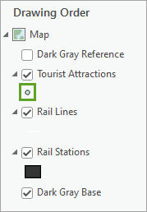

The **Symbology** pane appears. Symbology defines a layer's appearance. You can choose from a gallery of default symbols or customize a symbol.

1. In the **Symbology - Tourist Attractions** pane, on the **Gallery** tab, search for Tear Pin. In the list of results, click the largest **Tear Pin 1 (40%)** symbol.

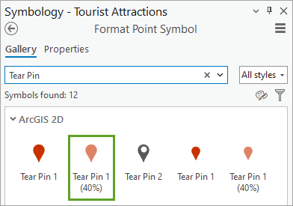

The symbols for tourist attractions change to the chosen symbol. The tear pin symbol helps convey that the tourist attractions are places of interest. The 40% indicates that the symbol is 40 percent transparent, which is useful in case the symbols obscure parts of the map.

You can make the symbols stand out more by adding an outline and increasing the symbol size.

1. Click **Properties**.

Properties option

1. Click the **Layers** tab.

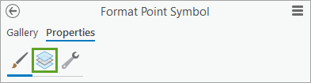

1. For **Outline color**, choose **Arctic White**.

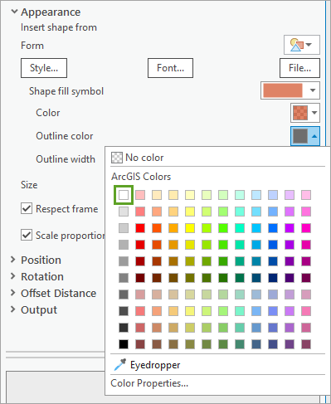

##### Tip:

To see a color's name in the color picker, point to it.

1. Change **Outline width** to 0.7 pt. Change **Size** to 22 pt.

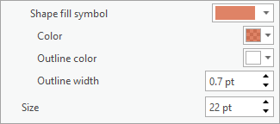

1. At the bottom of the **Symbology** pane, click **Apply**.

The new symbology is applied to the layer.

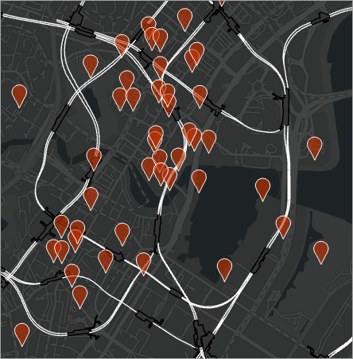

Now the tourist attractions stand out more clearly, without obscuring other map features.

##### Note:

If your ArcGIS account uses an ArcGIS Enterprise portal and you downloaded the layer data, the rail lines and rail stations may have different symbols than those shown in the example images. To change the rail lines symbol to match the example images, click its symbol to open the **Symbology** pane. On the **Properties** tab, on the **Layers** tab, change **Color** to **Arctic White** and click **Apply**. To change the rail stations symbol, open its **Symbology** pane. On the **Properties** tab, on the **Symbol** tab, change **Color** to **Gray 80%**, **Outline color** to **Black**, and **Outline width** to **1.2** pt. Click **Apply**.

1. Close the **Symbology** pane and save the project.

## Determine proximity

The tourism agency wants its brochure to indicate the closest rail station to each tourist attraction. Measuring the distance between each tourist attraction and rail station one by one would take a lot of time, so you'll automate the process by running a geoprocessing tool to gather all the information into a single layer.

A geoprocessing tool performs an operation on a dataset. In ArcGIS Pro, there are hundreds of geoprocessing tools, encompassing a wide variety of operations. You'll use the **Spatial Join** tool, which combines information from two feature classes based on their spatial relationship. You'll use this tool to determine the closest rail station to each tourist attraction.

1. On the ribbon, click the **Analysis** tab. In the **Geoprocessing** group, click **Tools**.

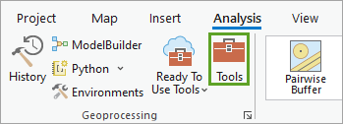

The **Geoprocessing** pane appears.

1. In the **Geoprocessing** pane, in the search bar, type Spatial Join. In the list of results, click the **Spatial Join** tool.

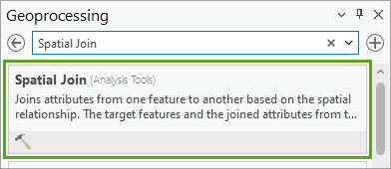

##### Tip:

Another way to open the Spatial Join tool is from the **Analysis Gallery**. On the **Analysis** tab, in the **Tools** group, expand the **Analysis Gallery**. In the **Overlay Features** group, click **Spatial Join**.

##### Note:

At the bottom of the **Geoprocessing** pane, you can choose to view the tools with description and details or as a list view.

The **Spatial Join** dialog box appears. Most geoprocessing tools have parameters you can set to change the tool's result. For this tool, you'll first choose the feature layers to join.

1. For **Target Features**, choose **Tourist Attractions**. For **Join Features**, choose **Rail Stations**.

##### Tip:

To learn more about any parameter, point to the parameter. Then, point to the information button that appears. A ToolTip appears with a description of the parameter.

Next, you'll set the **Output Feature Class** parameter. Many geoprocessing tools create an output layer, leaving the original layers unchanged.

By default, output layers are saved in a folder specialized for geographic data, called a geodatabase, that was created when you created the project. You'll leave the output location unchanged, but you'll change the output name.

1. For **Output Feature Class**, click the text box. Replace the text with Tourist_Attractions_Join.

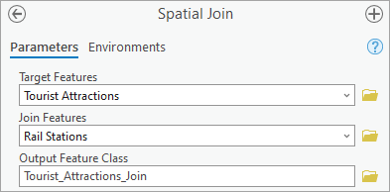

You'll leave the **Join one to one** operation unchanged. This operation ensures that each tourist attraction is joined to only one rail station, which is ideal for your purposes because you only want to know the single closest station.

Next, you'll set the **Match Option** parameter. This parameter determines the spatial relationship between the features to be joined.

1. For **Match Option**, choose **Closest**.
2. Below the visible parameters, expand **Fields**.

The **Field Map** parameter determines which attributes from each input feature class are kept in the output feature class. You'll learn more about attributes later. For now, you'll only remove the **Shape__Area** and **Shape__Length** fields, because you're not interested in the size and shape of the features on the map. The rest of the fields provide useful context for the user.

1. In the **Output Fields** column, click **Shape__Area** and click the **Remove** button.

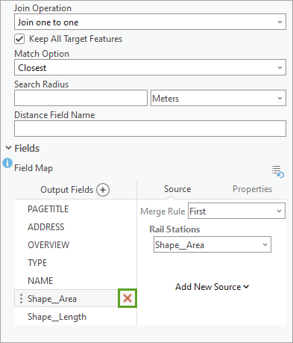

1. Remove the **Shape__Length** field.

You've set all the parameters you need. Based on the parameters you've chosen, the tool will run an operation that combines information from each tourist attraction with information from its closest rail station.

1. Click **Run**.

The tool runs. When it finishes, a new layer, **Tourist_Attractions_Join**, is added to the map and the **Contents** pane. The new layer looks similar to the original **Tourist Attractions** layer; however, the geoprocessing tool changed the layer's attributes.

Attributes are information associated with each feature in a feature layer. They may include the feature's name, address, area, or many other types of information. You can view a layer's attributes by opening its attribute table.

1. In the **Contents** pane, right-click **Tourist_Attractions_Join** and choose **Attribute Table**.

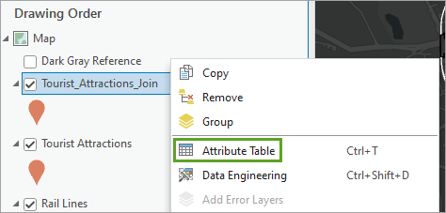

The attribute table opens.

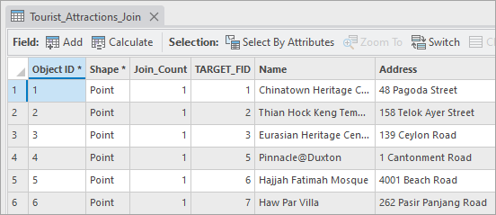

Each row of the table represents a single feature on the map and each column is a field of information. In this table, the first row corresponds to a feature named Chinatown Heritage Centre on 48 Pagoda Street.

* + The **Object ID** field contains a unique ID number for each feature.
  + The **TARGET_FID** field refers to the target features (**Tourist Attractions**) we selected for the spatial join.
  + The **Join_Count** field indicates the number of join features that match each target feature.

##### Tip:

You can resize the table by dragging the handle at the top of the table.

1. If necessary, scroll until you see the last few fields.

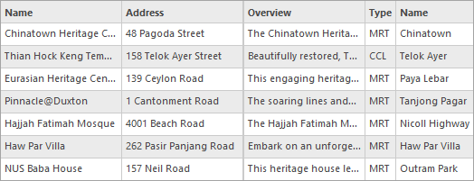

The table has two fields titled **Name**. While the first **Name** field is the name of the tourist attraction, the second **Name** field is the name of the closest rail station. The second **Name** field was added to the table after you ran the **Spatial Join** tool.

##### Note:

The **Type** field was also added by the **Spatial Join** tool. It indicates whether the closest station is part of the Massive Rapid Transit (MRT), Light Rail Transit (LRT), or Circle Line (CCL) system. You can determine the fields the tool added by opening the attribute table for the original **Tourist Attractions** layer and comparing.

1. Close the table.

You no longer need the original **Tourist Attractions** layer, so you'll remove it.

1. In the **Contents** pane, right-click the **Tourist Attractions** layer and choose **Remove**.

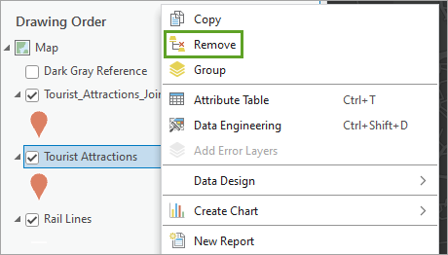

The layer is removed. You'll also rename the new layer so that its name matches the one you removed.

1. Click the **Tourist_Attractions_Join** layer name to select it. Click it again to make the layer name editable.
2. Change the name to Tourist Attractions and press Enter.

##### Tip:

Another way to change the layer name is to double-click it to open its **Layer Properties** window. On the **General** tab, change the name. Click **OK**.

1. Save the project.

## Export a table

If tourists accessed your map in ArcGIS Pro or as an interactive web map in ArcGIS Online, they could open the attribute table like you did to find the closest station to each attraction. However, this map will be printed in brochures, so users won't have that ability.

To accompany the map, the tourism agency plans to print key information from the attribute table in the brochure. You'll export the attribute table to a plain text file so the agency can copy the necessary data into the brochure design.

1. In the **Contents** pane, right-click **Tourist Attractions**, point to **Data**, and choose **Export Table**.

The **Export Table** window appears. This tool converts a layer's attribute table to a new file format. The **Tourist Attractions** layer is already selected for the **Input Table** parameter.

The default output location is the geodatabase that was created with the project, Singapore Tourism.gdb. However, a text file cannot be stored in a geodatabase. You'll change the output location to one appropriate for the data you're exporting.

1. For **Output Table**, click the **Browse** button.

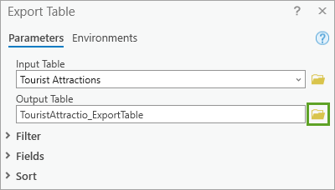

The **Output Table** window appears.

1. In the **Output Table** window, click **Folders** and double-click the **Singapore Tourism** folder.

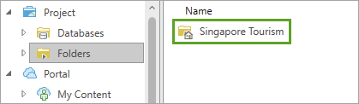

1. For **Name**, type Tourist_Attractions.txt. (Be sure to include the .txt extension.)

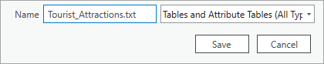

##### Note:

If you change the output location to a geodatabase, the tool will not run correctly; choose a location other than the default location.

1. Click **Save**.

##### Tip:

You can also export the table to a comma-separated values file using the .csv extension or a dBase database file using the .dBF extension.

As with the **Spatial Join** tool, the **Export Table** tool includes the option to remove fields from the output table. You'll remove the **Join_Count** and **TARGET_FID** fields, which don't provide necessary information for your purposes.

1. Expand **Fields**.
2. For **Field Map**, click the **Join_Count** field to select it and click the **Remove** button. Remove the **TARGET_FID** field in the same way.
3. Click **OK**.

The tool runs and the table is exported. (You can confirm it was exported successfully by checking the output location you chose). Additionally, the exported table is added to the **Contents** pane under the **Standalone Tables** heading . You don't need the table in the project, so you'll remove it.

1. In the **Contents** pane, right-click **Tourist_Attractions.txt** and choose **Remove**.
2. Close the **Geoprocessing** pane and save the project.

## Label features

With the exported table, the tourism agency can add the attribute information to the brochure as textual information. However, tourists using the brochure won't be able to tell which points on the map correspond to which tourist location.

To make the map more useful, you'll label the tourist attractions. Labels are textual information that appear on a map to help users understand the data.

1. In the **Contents** pane, click the **Tourist Attractions** layer to select it.

The **Labeling** tab becomes available. This tab is a contextual tab, meaning it only appears when it's relevant to the data you're working with.

1. On the ribbon, click the **Labeling** tab. In the **Layer** group, click the **Label** button.

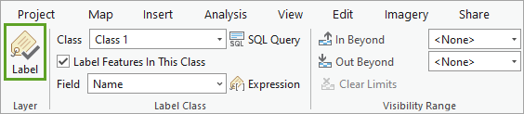

Labels are enabled for the layer. By default, each tourist attraction is labeled with its name. Because there are so many attractions, however, the labels clutter the map and aren't easy to read.

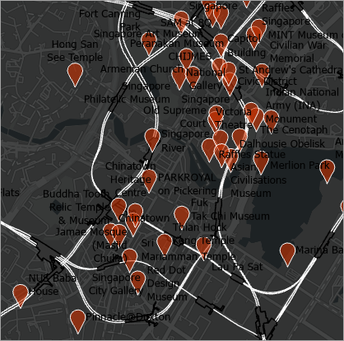

To make the map easy to read, you'll label attractions using their unique ID number instead.

1. In the **Label Class** group, for **Field**, choose **Object ID**. (You may need to scroll to see the correct option.)

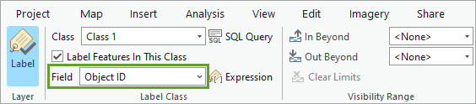

The labels on the map change from long names to smaller numbers. While the numbers don't immediately identify each attraction, the brochure can include the IDs with the table data to help users identify them.

The labels have small, dark text that doesn't show up well on the dark basemap. Additionally, the position of the labels doesn't always make it clear which number corresponds to which attraction. You'll change the appearance and position of the labels to make them clearer.

1. In the **Text Symbol** group, change **Text Symbol Font Size** to 8 and **Text Symbol Color** to **Arctic White**.

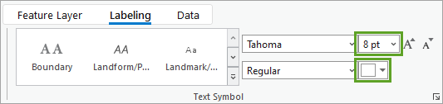

1. In the **Label Placement** group, click **Centered Point**.

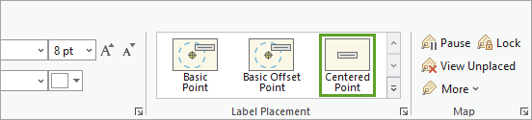

The labels are updated on the map.

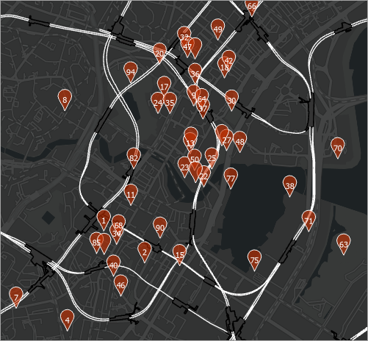

These labels are improved, but there are still a few small problems. First, for some tourist attractions, no labels appear. By default, labels are not displayed if they are too close together, to prevent overlapping. Additionally, the labels will look better if they were located more centrally in the pin symbol. You'll make changes to solve both of these problems.

1. In the **Label Placement** group, click the **Label Placement Properties** button.

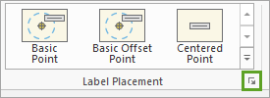

The **Label Class - Tourist Attractions** pane appears. This pane has advanced labeling options.

1. Click the **Conflict resolution** tab.

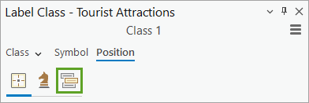

1. Expand the **Unplaced labels** section and check **Never remove (place overlapping)**.

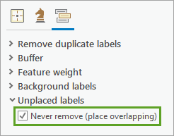

Now, no labels are removed from the map due to overlapping. Next, you'll adjust the label position so that it is located more centrally within each pin symbol.

1. Click **Symbol**. On the **General** tab, expand the **Position** section and change **Offset Y** to 2 pt.

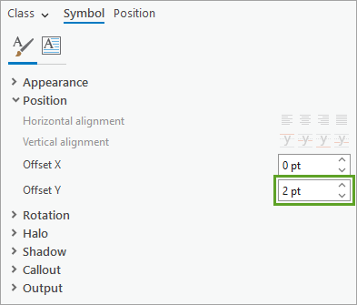

1. Click **Apply**.

The labels move up slightly, positioning them in the center of the pin symbols.

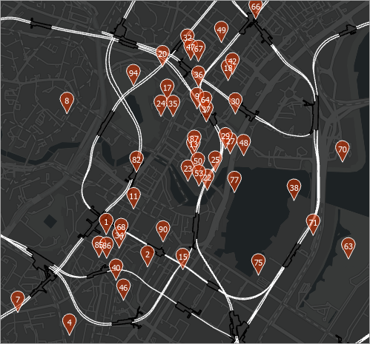

While some of the labels slightly overlap other pin symbols, they're all generally clear to read. In conjunction with table data published in the brochure, tourists will be able to identify every attraction on the map.

1. Close the **Label Class - Tourist Attractions** pane and save the project.

##### Note:

It may also be useful to users if the rail stations were labeled. For the purposes of this tutorial, you won't label them, but you can try creating your own labels. What kind of appearance do your labels need to be legible on the map?

Before you continue, you'll rename your map to something more descriptive. By default, its name is Map.

1. In the **Contents** pane, double-click **Map**.

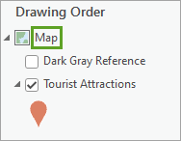

The **Map Properties** pane appears.

1. On the **General** tab, for **Name**, type Central Business District.

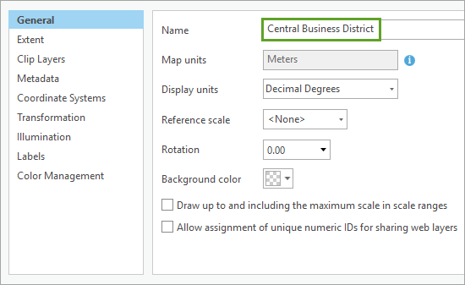

1. Click **OK**.

The map is renamed.

## Create a layout

Your map is finished. All that remains is to export it to a form that can be printed in the brochure. To prepare your map for printing, you'll create a page layout. A layout is a collection of map elements organized on a virtual page. It defines how your map will look when it's printed.

You can design a layout from scratch, but ArcGIS Pro also includes several layout templates. You'll use a template and modify a few layout elements.

1. On the ribbon, click the **Insert** tab and click the **Import Layout** button.

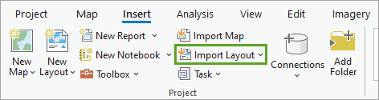

A list of available templates appears. A simple layout is best, as you want the emphasis to be on the map.

1. Choose the **Title Bar Letter Landscape** layout.

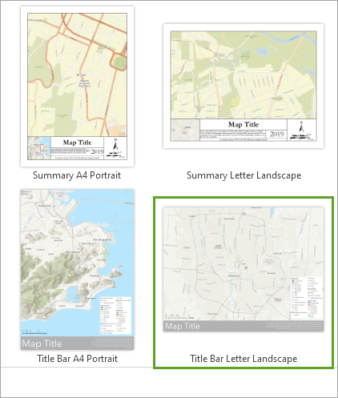

##### Note:

If you do not see a list of available templates, you can download and import the [layout template](https://www.arcgis.com/home/item.html?id=77C378CA3C584AD99615EC762208754F" \t "https://learn.arcgis.com/en/projects/get-started-with-arcgis-pro/_blank) used in this tutorial.

The layout opens as a new view. (You can switch between the map view and the layout view using the tabs above the view.)

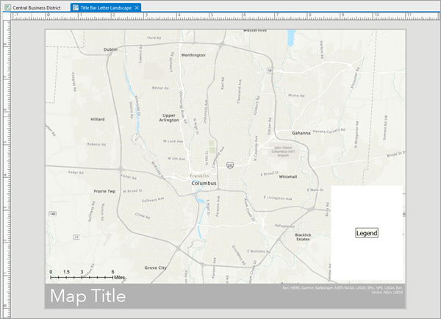

This layout includes a title, a legend, and a scale bar. All of the layout's elements are listed in the **Contents** pane. Additionally, the ribbon now displays tabs relevant to interacting with the layout.

By default, the template you chose contains a map of Columbus, Ohio. You'll update the layout's map frame to use your map of Singapore.

1. In the **Contents** pane, double-click **Map Frame**.

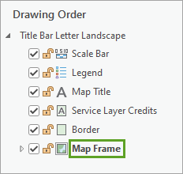

The **Map Frame** pane appears.

1. Under **Options**, for **Map Frame**, choose **Central Business District**.

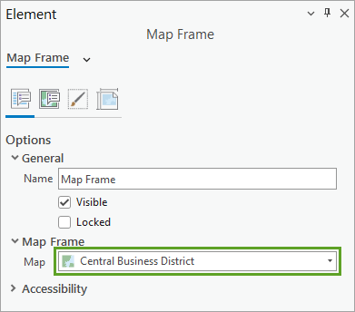

The map in the layout changes. However, the map is zoomed to a worldwide extent, and Singapore is not visible. The map extent and the layout extent are independent.

You'll use the bookmark you created earlier to navigate to your desired map extent.

1. On the ribbon, click the **Layout** tab. In the **Map** group, click **Bookmarks** and choose the **Central Business District** bookmark.

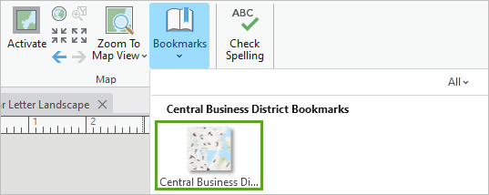

The map extent updates to your area of interest.

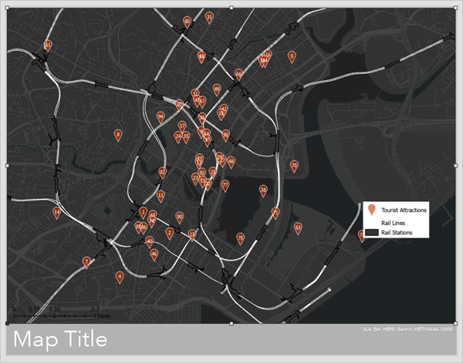

##### Tip:

To pan or zoom the map to a different extent in the layout, in the **Map** group, click **Activate**. Once activated, you can navigate the map normally. When you've changed the extent, click the **Layout** tab and click **Close Activation**.

Next, you'll title the layout.

1. In the **Contents** pane, double-click **Map Title**.

The **Map Title** pane appears.

1. Under **Options**, for **Text**, delete the existing text and type Downtown Singapore. Click anywhere outside the text box.

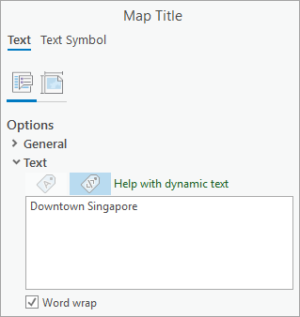

The change is applied to the layout.

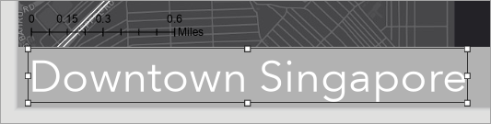

You'll also adjust the legend, which explains what all of the symbols on the map mean. The default legend has a white background, which means the white rail lines symbol doesn't show up well. You'll remove the background and adjust the legend's position.

1. In the **Contents** pane, double-click **Legend**.

The **Legend** pane appears. First, you'll change the legend text to white, so that it'll appear on the dark basemap when you remove the legend background.

1. Click **Text Symbol**. Expand **Appearance** and change **Color** to **Arctic White**.

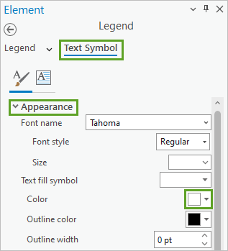

1. Click **Apply**.

Next, you'll change the legend background.

1. At the top of the pane, click the **Legend** drop-down arrow and choose **Background**.

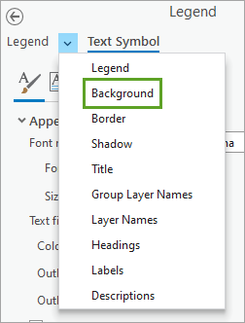

1. For **Color**, choose **No color**.

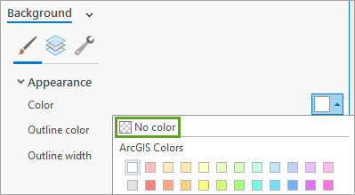

1. Click **Apply**.

The legend's background is removed.

1. In the layout view, drag the legend so that it appears in the lower corner of the map. When you're finished, click anywhere in the layout view outside of the map to deselect the legend.

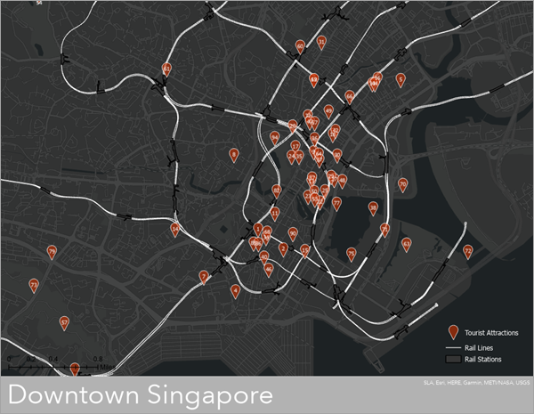

The scale bar is in the bottom corner, but difficult to see. Next, you'll update the scale bar appearance to make it more visible.

1. In the **Contents** pane, double-click **Scale Bar**.
2. In the **Element** pane, click the **Display** button.

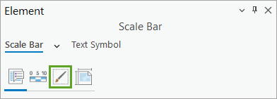

1. Under **Background**, change the following parameters:
   * For **Symbol**, change the color to **Grey 30%**.
   * For **X gap**, type 0.1.
   * For **Y gap**, type 0.1.
   * Click anywhere outside the text boxes to apply the changes.

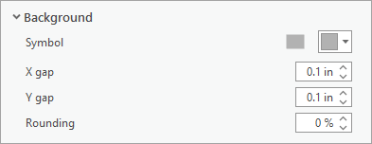

The scale updates with a grey background that matches with the title background.

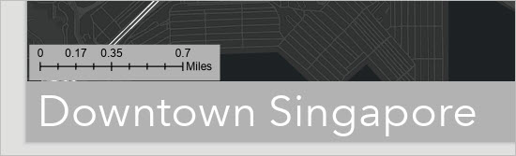

1. Click and extend the scale bar until the scale shows 1 mile.

Extended scale bar

1. Click and drag the scale bar to align with the edge of the layout and title.

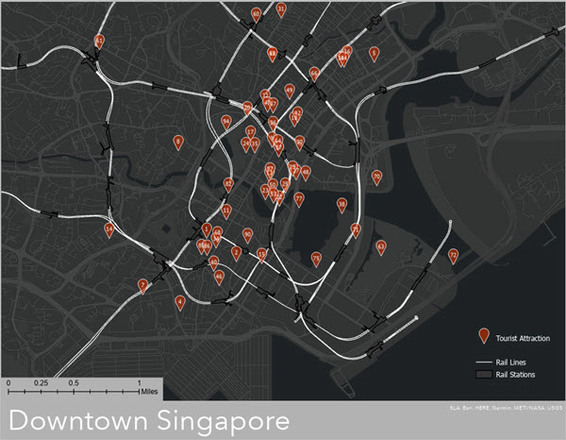

Your layout is complete. The tourism agency will print this map image on the inside of the brochure. The back of the brochure will contain a list of the tourist attractions based on the table you exported. Ultimately, the brochure will help tourists find the closest rail station to each tourist attraction.

1. Save the project.

Next, you'll export the layout to an image file.

1. On the ribbon, click the **Share** tab. In the **Output** group, click the **Export Layout** button.

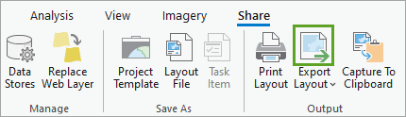

The **Export Layout** pane appears.

1. In the **Export Layout** pane, for **File Type**, choose your preferred image image file format. For **Name**, browse to your preferred output location and change the file name to Downtown Singapore.
2. Click **Export**.

The layout is exported to the location you chose.

--------------------------------------------------------------------------------------15/5/2023

Today I have created two shape files.

Ex . point and polygon with the help of arcgis pro tools.



A shapefile is one of the spatial data formats that you can work with and edit in **[ArcGIS](https://gisrsstudy.com/arcgis/" \t "https://gisrsstudy.com/create-shapefile/_blank)**. Geographic features in a shapefiles can be represented by ****points****, ****lines****, or ****polygons****.

The following data types are supported within a shapefile:

* Short Integer
* Long Integer
* Float
* Double
* Text
* Date

### **Create a Shapefiles (Vector file) in ArcGIS**

****1****. From the right side, **[Catalog](https://gisrsstudy.com/arcgis-catalog/" \t "https://gisrsstudy.com/create-shapefile/_blank)**window select the folder, click right button of the mouse, then ****New****> ****Shapefile****.

****2****. In the Create New Shapefile dialog box, write down the name of the shapefile and choose Feature Type.

On the Spatial Reference Section, click the Edit button and select ****Geographic Coordinate Systems-WGS 1984****. Finally, click the OK button to close the Create New Shapefiles dialog box.

New shapefiles is automatically add in contents (TOC) pane.

---------------------------------------------------------------------------------------------------------------------------------------

ReactJS-youtube,udemy (Learning vedios with practical)

---------------------------------------------------------------------------------------------------------------------------------------------